Supervised and Unsupervised Learning

Learning Graded Project

Week 4
Table of Contents
Problem 1 3
A Data Ingestion 3
1.1 Read the dataset. Do the descriptive statistics and do the null value condition check. Write an inference on it. 3
1.2 Perform Univariate and Bivariate Analysis. Do exploratory data analysis. Check for Outliers. 5
B Data Preparation 11
1.3 Encode the data (having string values) for Modelling. Is Scaling necessary here or not? Data Split: Split the data into train and test (70:30). 11
C Modeling 11
1.4 Apply Logistic Regression 11
1.5 Apply KNN Model and Naïve Bayes Model. Interpret the results. 12
1.6 Model Tuning, Bagging (Random Forest should be applied for Bagging) and Boosting. 14
1.7 Performance Metrics: Check the performance of Predictions on Train and Test sets using Accuracy, Confusion Matrix 17
Model Tuning (Grid Search Random Forest) 21
D Inferences 22
1.8 Based on these predictions, what are the insights? 22
Problem 2 24
Text Analysis 24
2.1 Find the number of characters, words, and sentences for the mentioned documents 24
2.2 Remove all the stopwords from all three speeches 24
2.3 Which word occurs the most number of times in his inaugural address for each president? Mention the top three words. (after removing the stopwords) 24
2.4 Plot the word cloud of each of the speeches of the variable. (after removing the stopwords) 24

Problem 1
You are hired by one of the leading news channels CNBE who wants to analyze recent elections. This survey was conducted on 1525 voters with 9 variables. You have to build a model, to predict which party a voter will vote for on the basis of the given information, to create an exit poll that will help in predicting overall win and seats covered by a particular party.

A Data Ingestion

1.1 Read the dataset. Do the descriptive statistics and do the null value condition check. Write an inference on it.

First 5 rows of the data
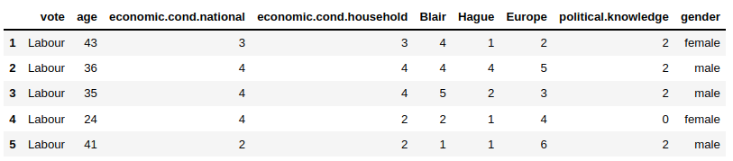
Information of the data and datatypes of each respective attribute:
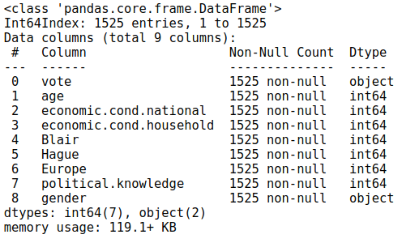
EDA Descriptive Statistics:
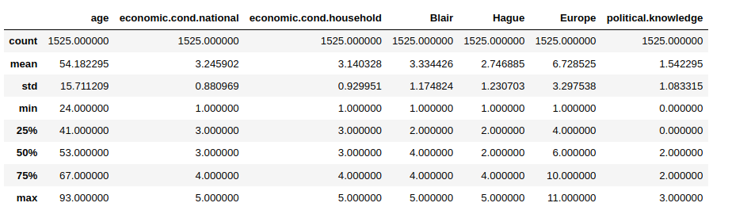
Check for Null Values:
There is no null values.
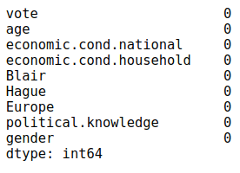
Check for dublicated values:
There was found 8 dublicated rows
Dropping these values
Before: (1525, 9)
After: (1517, 9)

Inferences:
- On performing the descriptive analysis, we can see that there are a few columns having categorical values but are not having the data type “object”
- The Election dataset have 1525 rows and 9 columns. All the variables except vote and gender are int64 datatypes.
- ‘vote’ have two unique values Labour and Conservative, which is also a dependent variable.
- ‘gender’ has two unique values male and female.
- There are no null values in the data set.
- There are 8 duplicate rows. Even though they could represent different person with exact same profile and political outlook, we drop these rows as they are few in number and add no value to the data set.

1.2 Perform Univariate and Bivariate Analysis. Do exploratory data analysis. Check for Outliers.
Univatiate Analysis
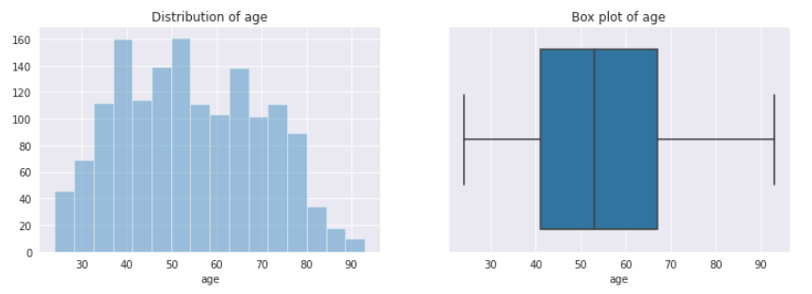
Distribution of ‘age’ resembles normal distribution and is slightly right skewed. Most of the respodent in the data is in age between 40 and 65.
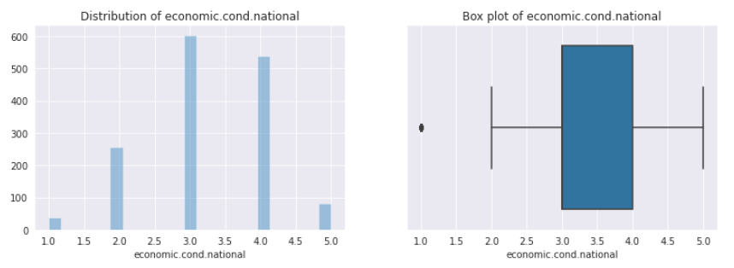
Distribution of ‘economic.cond.national’ isn’t normal distribution and is slightly left skewed. Out of the 1525 participants around 600 participants rated the national economic condition as more than average
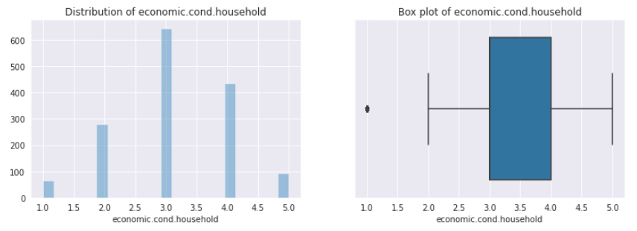
Distribution of ‘economic.cond.househols’ isn’t normal distribution and is slightly left skewed.

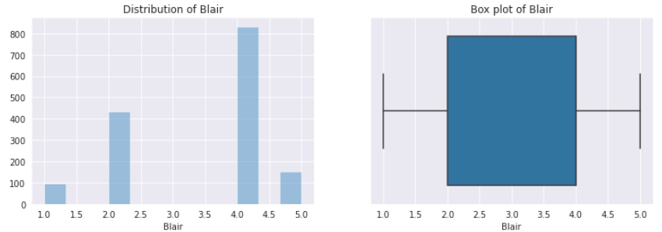
Distribution of ‘Blair’ isn’t normal distribution and is slightly left skewed, because mode is greater than mean.
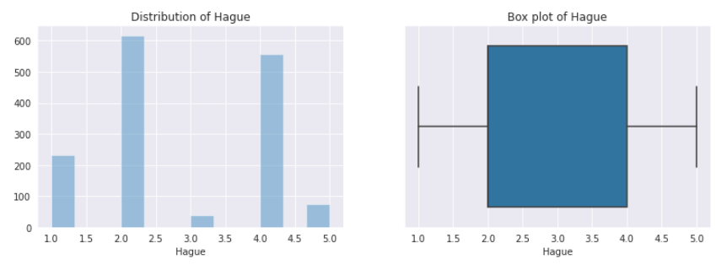
Distribution of “Hague” is not normal and it is slightly right skewed. This variable is not normally distributed and skewed.
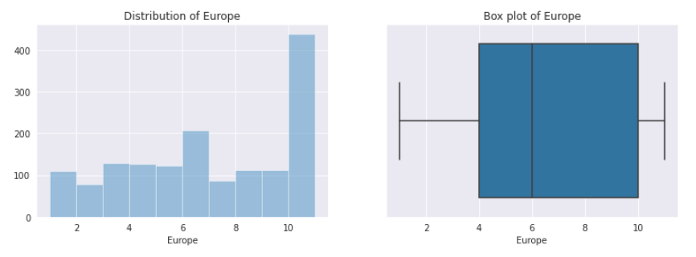
Distribution of “Europe” is somewhat normal and it is left skewed. Mode is higher than Mean. More than a half of participants have given rating of more than 6 in the scale, which shows that majority of the participants are much sceptical about European integration.
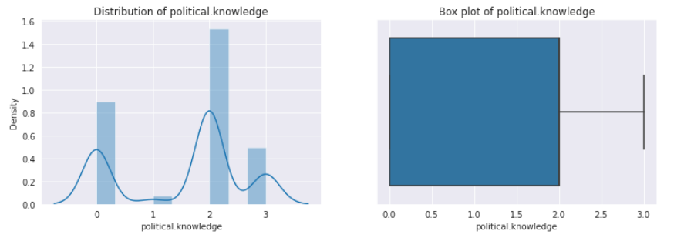
Distribution of “political.knowledge” is not normal and it is slightly right skewed.
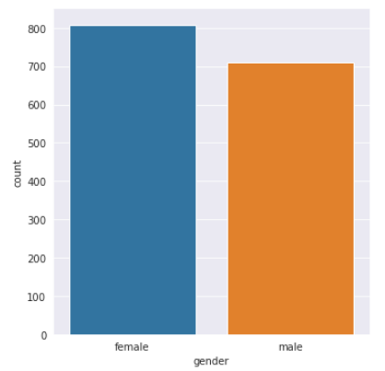
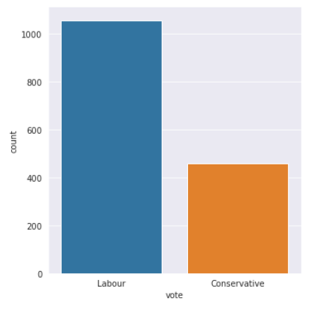
Most of the respodents in the data are women.
About 70 % of participants have chosen Labour party

Bivatiate Analysis
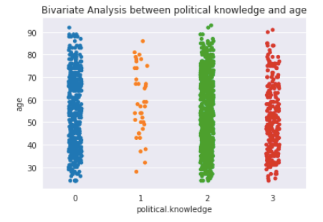
It seems that respodents have a moderate understanding of the political situation.
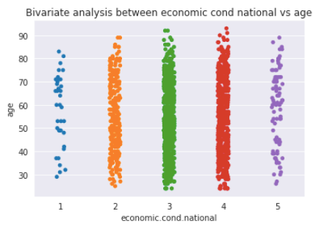
Majority of respondent rated the national economic condition as more than average
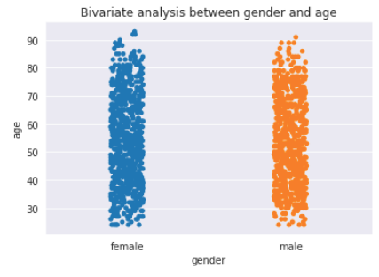
The population of both middle-aged male and female is more than the other ages.
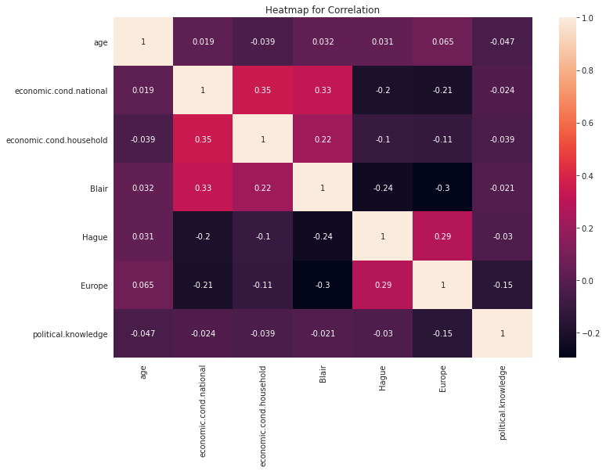
Heatmap for Correlation
There are no highly correlated variables
Check ouliers
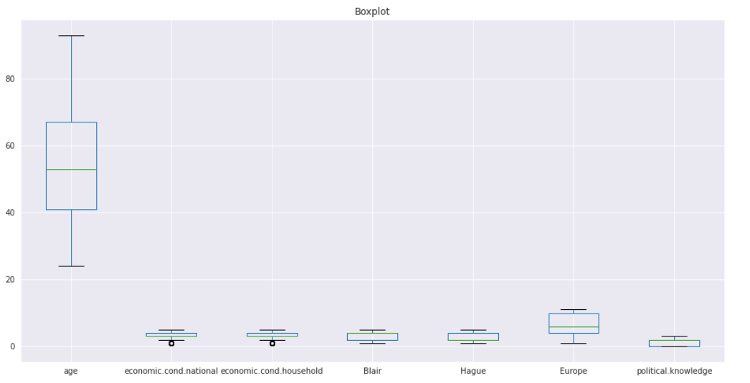
On performing the outliers analysis, we can see that there are a few outliets,

Pairplot for checking the correlation:
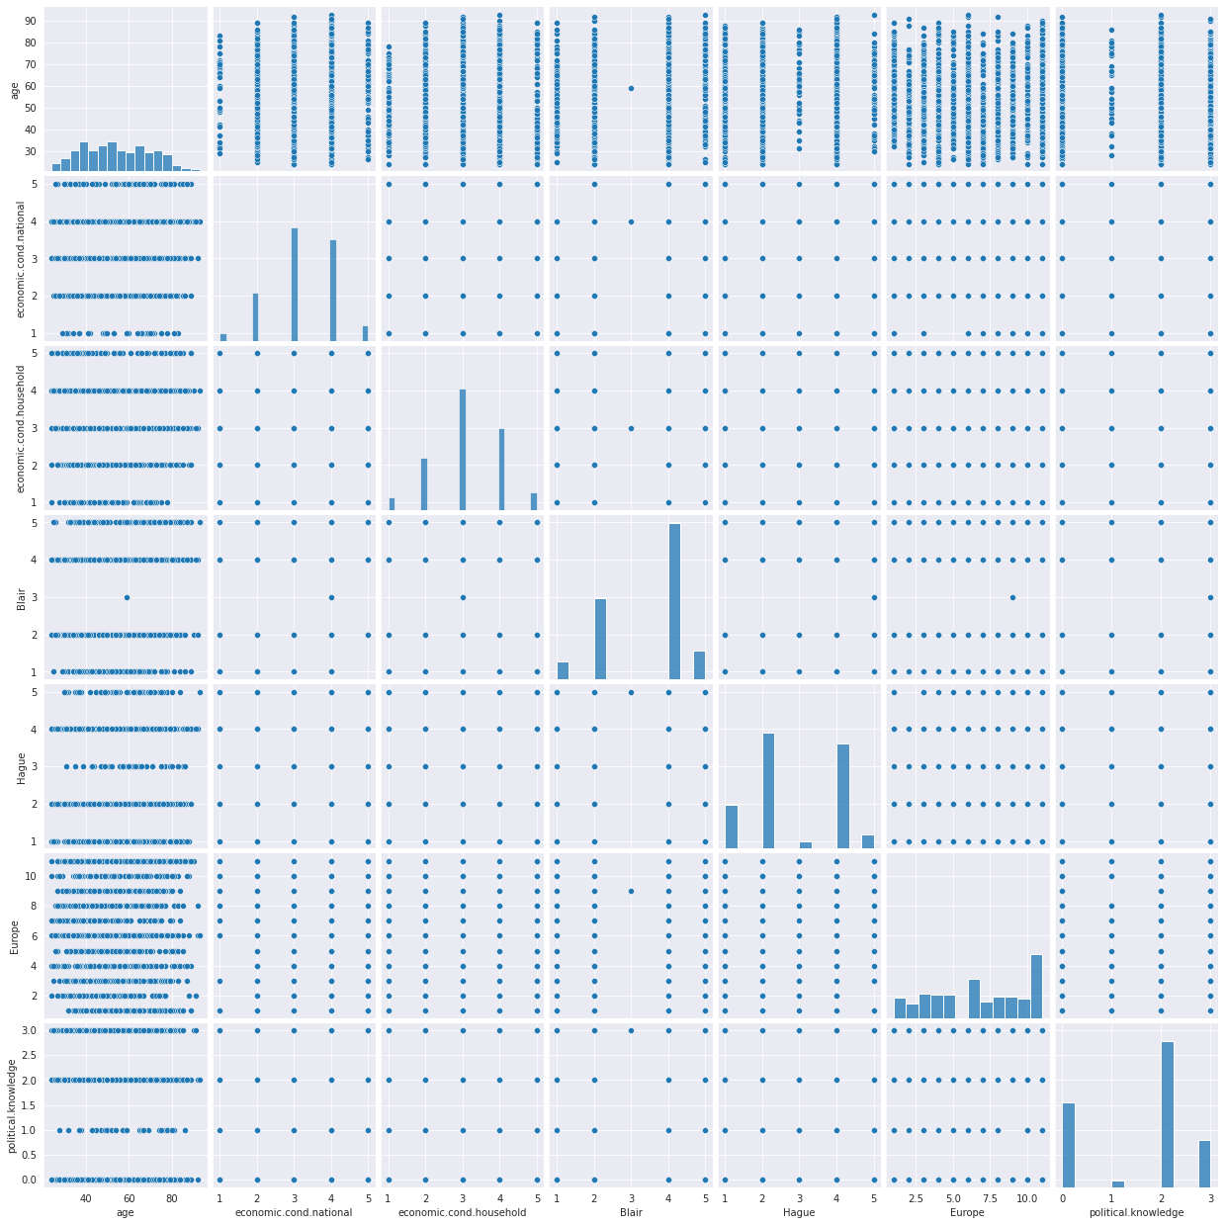
Inferences:
- None of variables are highly correlated with each other•
- Ratings of 0, 2 & 3 on Political Knowledge of parties' positions on European integration has not been influenced by different age groups.
- About 70 % of participants have chosen Labour party

B Data Preparation

1.3 Encode the data (having string values) for Modelling. Is Scaling necessary here or not? Data Split: Split the data into train and test (70:30).
Linear regression model does not take categorical values so that we have encoded categorical values to integer for better result.
Vote and Gender variables are encoded using replace method. Vote, are label encoded :Labour : 0
Conservative : 1. Gender: Female:0, Male:1
We split the data into train and test set in a 70:30 ratio to perform further analysis and building our machine learning models.
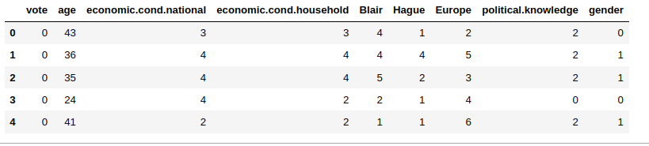
Scaling is required as continuous variables are of different scales and need to normalize the data using Standard Scaler.

C Modeling

1.4 Apply Logistic Regression
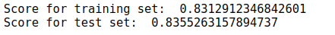
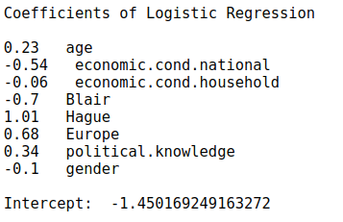

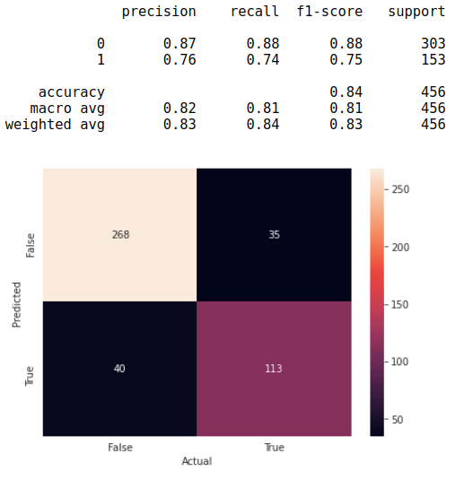
- The model score seems to be pretty good in both training and testing instance and this looks like a fairly good model.
- The Test and Train performance is within the accepted limited of +/- 10% which makes it an acceptable model as well.
- Accuracy & prediction is good. The model is able to detect properly to predict which party a voter will vote to win the election.

1.5 Apply KNN Model and Naïve Bayes Model. Interpret the results.
KNN
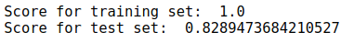
- Training shows that the model is excellent with good precision and recall values.
- This KNN model have good accuracy and recall values.
- The Test and Train performance isn’t within the accepted limited of +/- 10% which makes model overtrained.

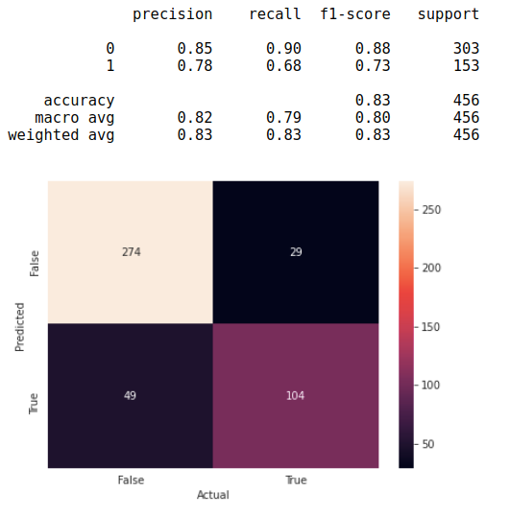
Naïve Bayes Model
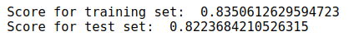
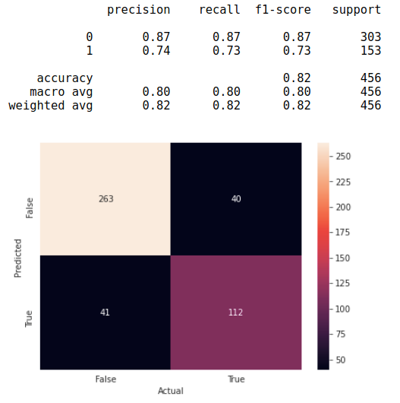
- Training and Testing results shows that the model neither overfitting nor underfitting.

1.6 Model Tuning, Bagging (Random Forest should be applied for Bagging) and Boosting.
Random Forest
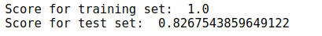
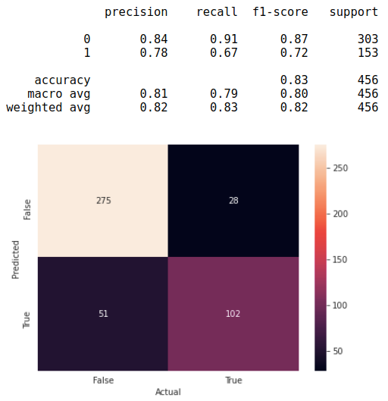
Bagging (Random Forest)
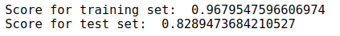
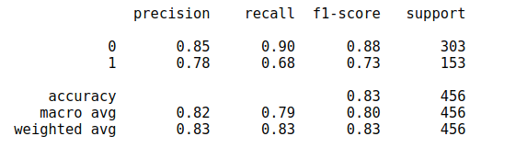

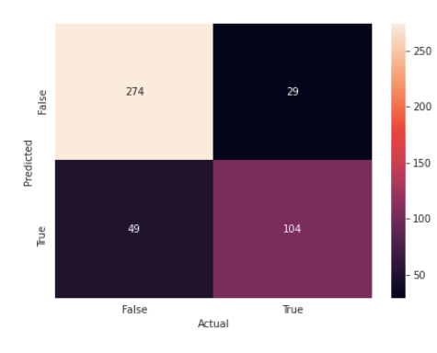
AdaBoost Model
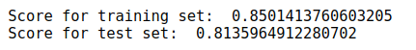
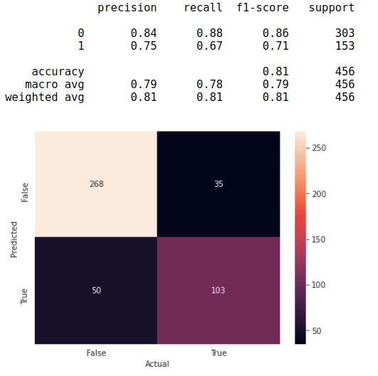
Gradient Boosting
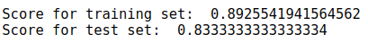
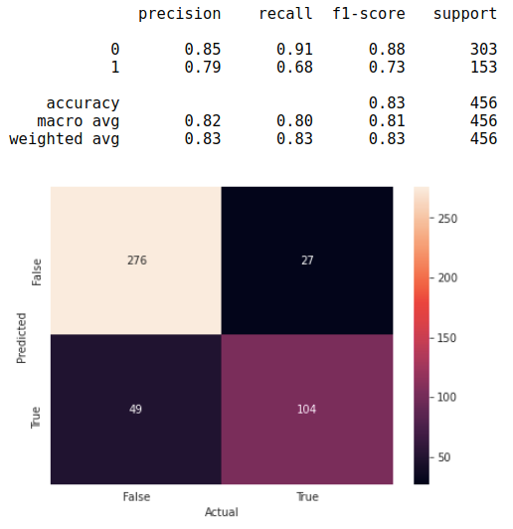
Model Tuning (Grid Search Random Forest)
GridSearchCV(cv=5, estimator=RandomForestClassifier(),
param_grid={'max_depth': [7, 8, 9, 10, 11, 12],
'max_features': [3, 5, 8, 10],
'min_samples_leaf': [5, 10, 15],
'min_samples_split': [50, 100],
'n_estimators': [100, 125, 150]})
Best params : {'max_depth': 12, 'max_features': 3, 'min_samples_leaf': 10, 'min_samples_split': 50, 'n_estimators': 125}
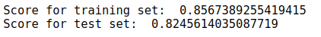
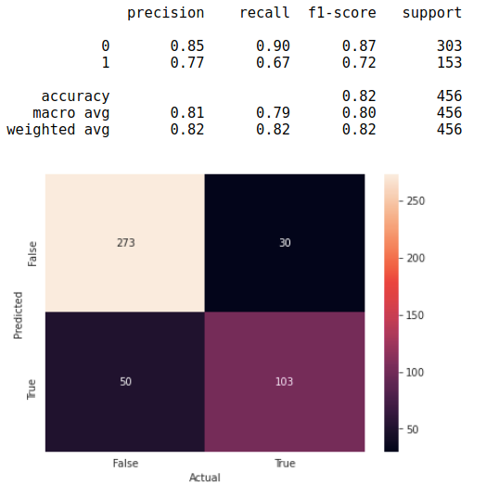

1.7 Performance Metrics: Check the performance of Predictions on Train and Test sets using Accuracy, Confusion Matrix
Logistic Regression
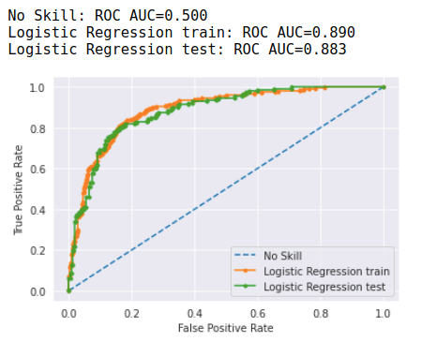
KNN
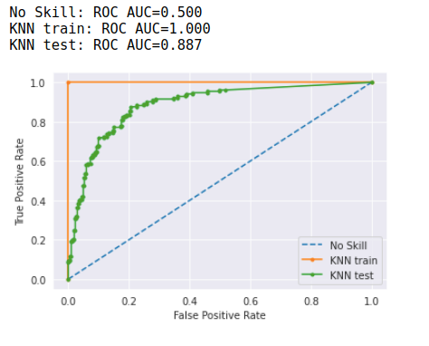
Naïve Bayes Model
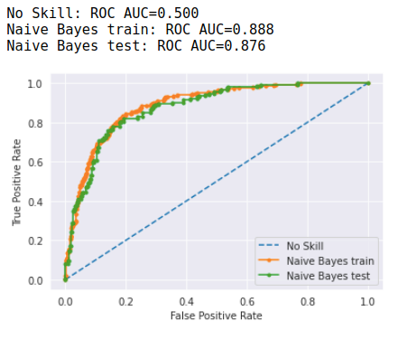

Random Forest
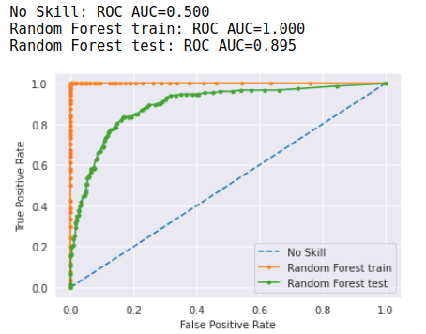
Bagging (Random Forest)
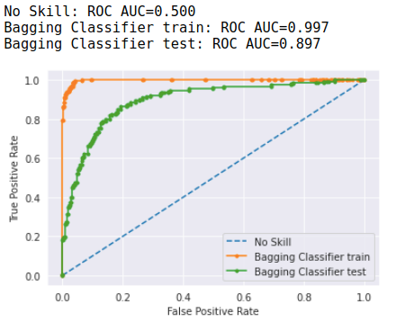

AdaBoost Model
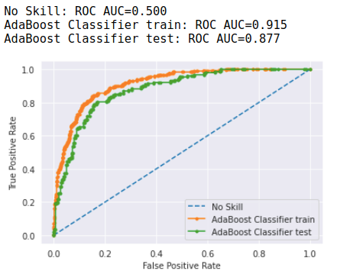
Gradient Boosting
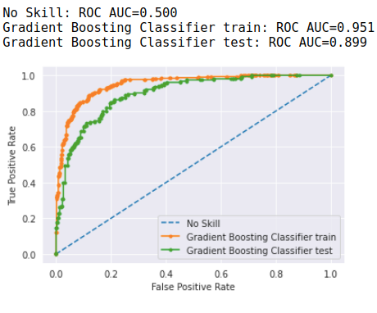

Model Tuning (Grid Search Random Forest)
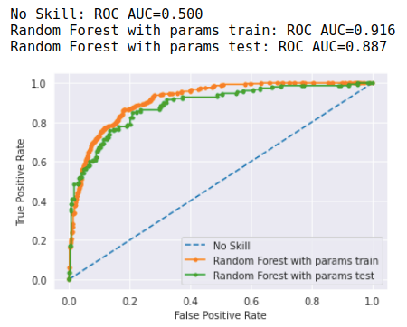

D Inferences

1.8 Based on these predictions, what are the insights?
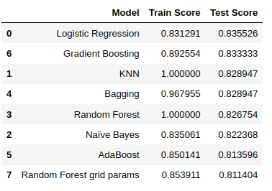
Inferences:
- Logistic Regression can be used to make predictions on the exit poll as to whether a particular voter would vote the Conservative or the Labour party based on the information provided.
- Majority of the population is between the ages 35-60 with considerable political knowledge and would vote mostly for Labour party.
- Bagging model is not very suitable and has overfitting issues
- Remaining models are relatively suitable for making predictions. However, the predictions are more reliable for Labour party
- Except Bagging, KNNand Random Forest other models have performed well enough in both training and test data set
- Accuracy is almost similar – in between 81 – 83%
- Accuracy & prediction is good. Hence both the model’s performance is approx. equal.
- The model is able to detect properly to predict which party a voter will vote to win the election.
- The accuracy of KNN model is very good compared to other models on train set but the accuracy decreases massively on testing data
- These Models should perform even better
- Even after applying Model Tuning, bagging & boasting did not improve performance of models.
- None of the model is performed properly.
SMOTE
About 70 % of participants have chosen Labour party. To solve this problem of not equaly distributed data, we will use SMOTE to generate more additional data for Conservative class (0)
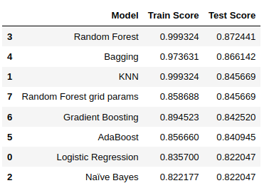
- Accuracy is have increased, and now it is between 82 – 87%
- According to the results: top 3 models with the highest score are slightly overtrained
- Bagging and Random Forest are showing better results for 5%

Problem 2

Text Analysis
In this particular project, we are going to work on the inaugural corpora from the nltk in
Python. We will be looking at the following speeches of the Presidents of the United States
of America:

- President Franklin D. Roosevelt in 1941
- President John F. Kennedy in 1961
- President Richard Nixon in 1973

- Find the number of characters, words and sentences for the mentioned documents.
- Remove all the stopwords from all the three speeches.
- Which word occurs the most number of times in his inaugural address for each
- president? Mention the top three words. (after removing the stopwords)
- Plot the word c

2.1 Find the number of characters, words, and sentences for the mentioned documents
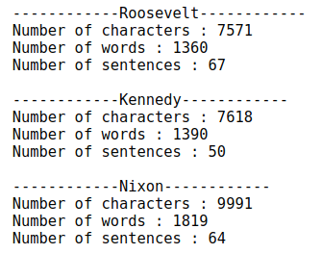

2.2 Remove all the stopwords from all three speeches
We need these to remove all the English predefined words from each text file separately and with the help of tokenize we would separate each word and remove all the words from the text file.
After removing stop words and punctuation marks, quatity of words has decreased by a factor of two.
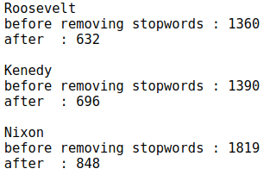

2.3 Which word occurs the most number of times in his inaugural address for each president? Mention the top three words. (after removing the stopwords)
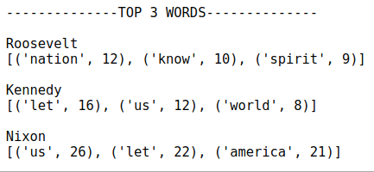
Roosevelt’s most common top three words, post removing stopwords are: Nation, Know and Spirit.
Kennedy’s most common top three words, post removing stopwords are: Let, Us and World.
Nixon’s most common top three words, post removing stopwords are: Us, Let and America.

2.4 Plot the word cloud of each of the speeches of the variable. (after removing the stopwords)
Word Cloud is a data visualization technique used for representing text data in which the size of each word indicates its frequency or importance. Significant textual data points can be highlighted using a word cloud. Word clouds are widely used for analysing data from social network websites.
Here we are creating the wordcloud for Roosevelt speech and we have imported the wordcloud by importing libraries.

Roosevelt
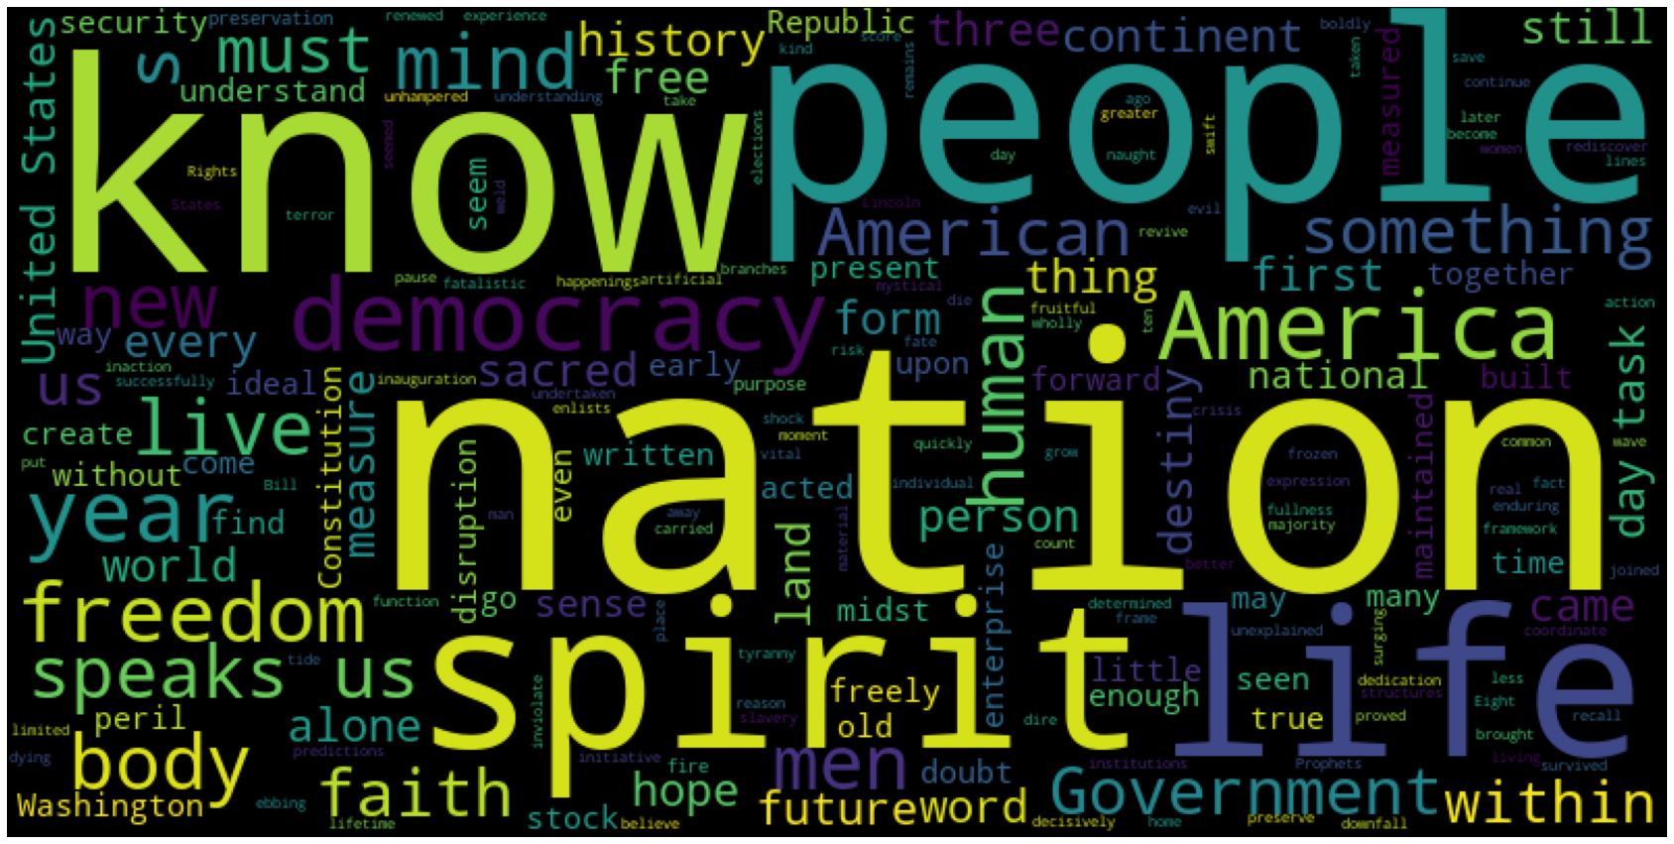
Kennedy
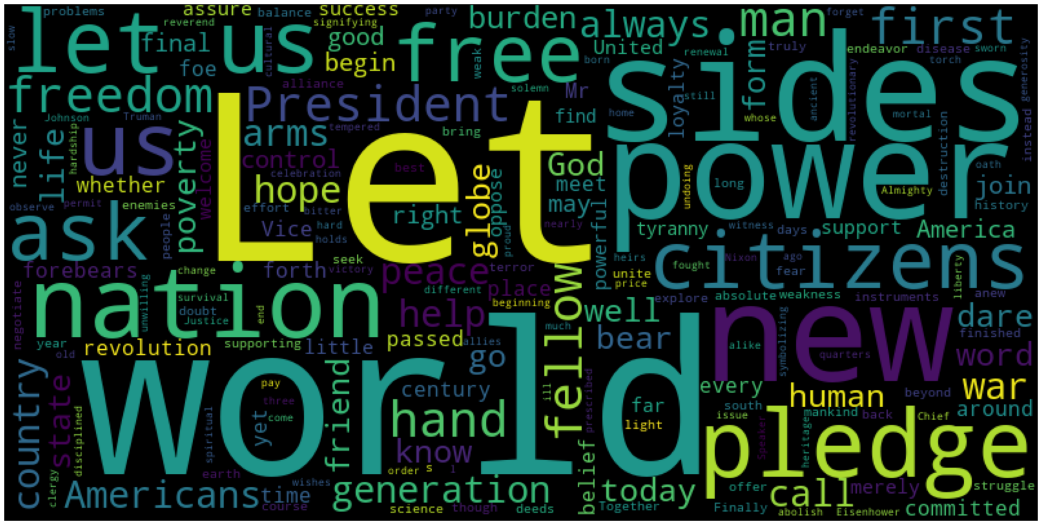

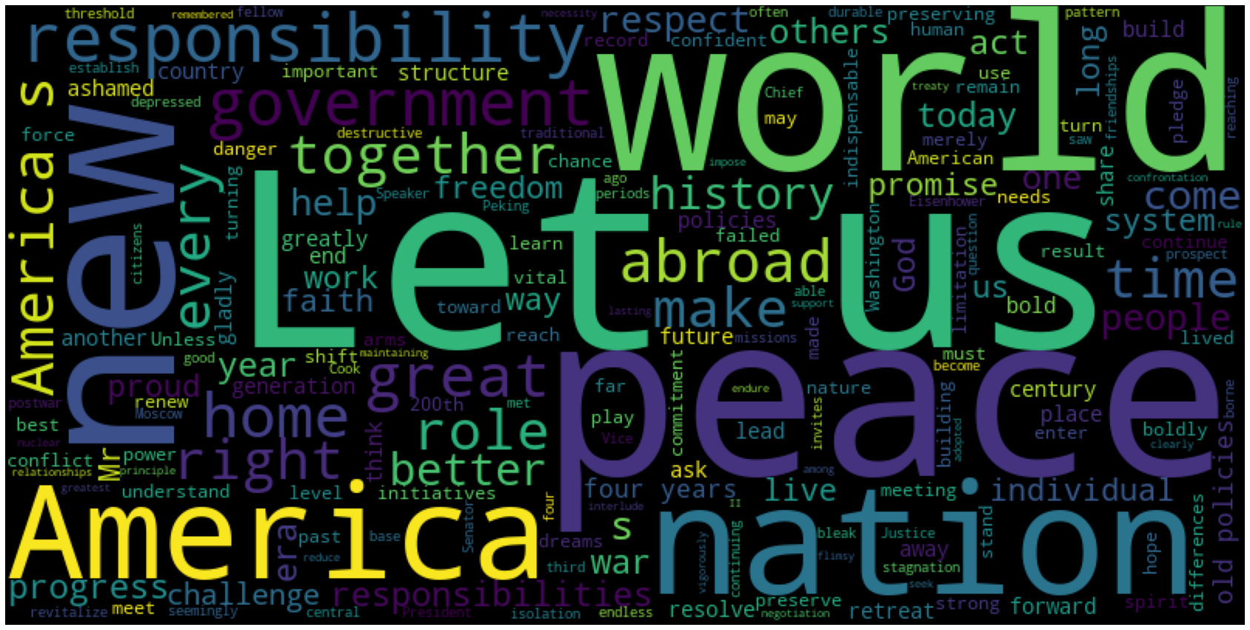
Nixon

